**General Physics Laboratorium**

Ex #29

Topic: DETERMINATION OF THERMAL EXPANSION COEFFICIENT

|  |  |
| --- | --- |
|  |  |
| Name, Surname | Nykonchuk Illia, 245693, W08 |
| Time of classes: | Tuesday, 17:05-18:45 |
| Number of group : | Z00-33d |
| Date of submit: | 20.04.2020 |
| **Grade:** |  |

Approving the measurement results.

Date and signature of the lecturer **............................................................**

Introduction

Thermal expansion is the tendency of matter to change its shape, area, and volume in response to a change in temperature. Goal of the exercise is to determine the thermal expansion coefficient of an investigated metal phenomenon where an object or body expands in reaction to being heated

Steps

1. Construct measurement setup
2. Measure initial values of temperature and length of the wire.
3. Change the value of current flowing through the wire and measure the temperature of the wire and ΔL
4. Plot the graph of relative elongation ΔL/L0 versus ΔT
5. Fit data with linear regression y=Ax+B
6. Based on the measured value of α determine the metal constituting the wire.

Scheme of a measurement setup

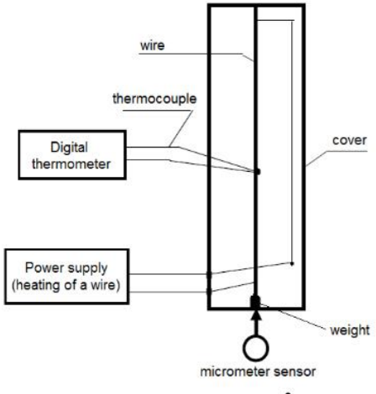

Measurement Values

Initial temperature t0 = 21.4°C; u(t) = 5% of value +0.5°C

initial length L0 = 0.885 ± 0.004 m, u(ΔL) = 0.01 mm

|  |  |  |  |  |  |  |
| --- | --- | --- | --- | --- | --- | --- |
| t0 (°C) | u(t0) (°C) | ΔL (mm) | ΔT (°C) | u(ΔT) (°C) | ΔL/L0 * 10-3 (mm) | u(ΔL/L0)  (mm) |
| 23 | 1.65 | 0.03 | 1.6 | 0.58 | 0.034 | 0.012 |
| 28.3 | 1.92 | 0.13 | 6.9 | 0.85 | 0.147 | 0.013 |
| 36.4 | 2.32 | 0.22 | 15 | 1.25 | 0.249 | 0.013 |
| 44.8 | 2.74 | 0.33 | 23.4 | 1.67 | 0.373 | 0.014 |
| 55.7 | 3.29 | 0.53 | 34.3 | 2.22 | 0.599 | 0.014 |
| 68.2 | 3.91 | 0.71 | 46.8 | 2.84 | 0.803 | 0.015 |
| 82.1 | 4.61 | 0.81 | 60.7 | 3.54 | 0.915 | 0.016 |
| 96.6 | 5.33 | 1.03 | 75.2 | 4.26 | 1.164 | 0.017 |
| 109.1 | 5.96 | 1.27 | 87.7 | 4.89 | 1.436 | 0.018 |
| 124.8 | 6.74 | 1.48 | 103.4 | 5.67 | 1.673 | 0.019 |
| 141.6 | 7.58 | 1.71 | 120.2 | 6.51 | 1.933 | 0.020 |

Examples of calculations

ΔT = T - T0 = 23.0-21.4 = 1.6 °C

u(t) = 0.05*23 + 0.5°C = 1.65°C

u(ΔL/L0) = ΔL/L0 *((u(L0)/L0)*100 + (u(ΔL)/ ΔL)*100) mm

ΔL/L0 = $\frac{0.03mm}{885mm}=0.0000338983 mm=0.034*{10}^{-3}mm$

Where ΔT = initial temperature – t0

Analysis of the values

Linear regression: y = 0.01584x+0.0211

Where y = ΔL/L0, x=ΔT, A = a, u(A) = u(a)

u(A) = 0.00026 1/oC,

So, the value of thermal expansion coefficient is (0.01584+- 0.00026) * 10^3 1/oC

Conclusion

The linear expansion coefficient was determined in the exercise based on the graph of the relation of the relative elongation of the wire as a function of temperature. It is equal to the tangent of the angle of inclination of this graph. Calculations were made for data for which this relationship is linear (i.e. for a temperature of 21.4 to 141.6). By received thermal expansion coefficient and the table of thermal expansion coefficients from the table we can determine that wire is constituted by copper (16-16.7 1/oC ).

Source of thermal expansion coefficient table:

<https://www.engineeringtoolbox.com/linear-expansion-coefficients-d_95.html>